Examining the Performance of the Multi-Core Workstation and High-Performance Computing

Prepared by: Christopher Brunswick & Keith McBride

for

Capstone Design 2

Savannah River Nuclear Solutions Remediation and Environmental Cleanup Services

April 29, 2021

**Abstract**

Every two years, Savannah River Site examines the inside of the H-Canyon Exhaust Tunnel (HCAEX) under the Structural Integrity Program. Tunnel inspections have been performed using cameras on mounted crawlers or placed within the tunnel through access pipes. Currently, tunnel interior examinations are being performed with a Light Detection and Ranging (LiDAR) unit to evaluate the usefulness of the data collected. The grounds for the LiDAR examinations are to ascertain if LiDAR data could be remotely transmitted to computers stationed above ground from within the walls of the HCAEX tunnel and whether the results from the LiDAR examinations would provide quantitative data of the tunnel’s interior to determine the erosion rate over multiple deployments. Each deployment involves using a Leica BLK360 Laser scanner LiDAR unit to collect and analyze point cloud data processed on a Savannah River Nuclear Laboratory (SRNL) multicore workstation through the 3D point cloud processing software CloudCompare. This software will show 360° of HCAEX’s interior surfaces. Unfortunately, CloudCompare’s processing ability is hindered due to the limited cache size and core count of SRNL’s multicore workstation. This ultimately increases the execution time of each data set tremendously, with the longest execution time being around 4 hours. High-performance computing is suggested in order to reduce the execution time. This report will detail the steps taken to access, analyze, and process point cloud data on CloudCompare through high-performance computation and compare the end results obtained by both the University of South Carolina High Performance Computer Hyperion and SRNL’s multicore workstation.

**Introduction**

The H-Canyon Exhaust Tunnel (HCAEX), as seen in Figure 1, is an underground reinforced concrete tunnel periodically examined under the H-Area Structural Integrity Program (SIP).

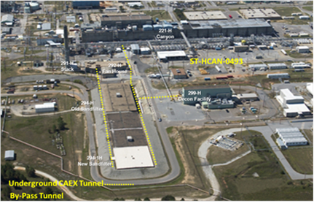 *Figure 1*: *Image of the location of the H-Canyon Area Exhaust Tunnel*

*H-Canyon Air Exhaust Tunnel Inspection Vehicle Development,* an article by SRNL staff Richard L. Minichan, Robert F. Fogle, and Athneal D. Marzolf, states, “Its makeup is a large ventilation system attached to the H-Canyon facility that maintains negative pressure in process areas for radioactive contamination control and personnel protection” (Minichan et al.). The air exhaust tunnel’s purpose is to direct hazardous air, produced from processing nuclear waste to a sand filter to clean it. In addition, according to the *November 2019 Initial Deployment of LiDAR Revision* report, a report prepared by H-Area Engineers J. M. Carter and S. Z. Bowers and SRNL staff J. R. Plummer and W. W. Wells, “the SIP fulfills in-service examinations of SC and Safety Significant passive design features to confirm conditions can fulfill their credited safety function” (Carter et al. 6). The program guarantees that if evidence of degradation is perceived, appropriate measures can be taken, accordingly, to ensure the safety function. In order to get a visual of the degradation within the interior of the tunnel, cameras placed on mounted crawling devices traverse the routes of the tunnel or placed within the tunnel through an existing pipe penetration, as seen in Figure 2. 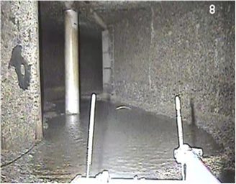

*Figure 2*: *Captured image of HCAEX interior from camera on mounted crawler*

The crawling devices were replaced due to their inability to travel across obstacles effectively. Therefore, LiDAR technology has been implemented, which obtains a 3-Dimensional mapping of the tunnel interior. The *November 2019 Initial Deployment of LiDAR* report states that, “the purpose of 3 Dimensional mapping is to provide measurable dimensions within the tunnel and that any alterations recorded in the tunnel interior dimensions between the periodic examinations would allow establishment of a rate of surface change, signifying a rate of erosion” (Carter et al. 7). Data is collected using the Leica BLK360 LiDAR system every six months, since 2019, however, “LiDAR is not a part of the official Structural Integrity Program” (J.Plummer, new abstract for report, April 5, 2021). A LiDAR assembly is needed in order to obtain scans of the tunnel’s interior. The *November 2019 Initial Deployment of LiDAR* report discloses the full design of the LiDS assembly:

“the LiDAR assembly consists of a pole that could be lifted with a crane,

be inserted into a 6-inch pipe and be adjusted to three elevations within the

tunnel to scan the tunnel interior. The assembly is customized to provide

continuous power for the Leica unit operations versus reliance on battery

power to eliminate the need to retrieve the pole due to low battery power.

Additionally, at the end of the pole were four dimmable Light Emitting Diode

(LED) light stripes for illuminating the light deprived environment and whose

intensity is controllable from the above ground control station. A Wi-Fi access

point is mounted at the top bottom section of the pole to bridge the communication

network from the underground LiDAR to the above ground remote-control station

where a second Wi-Fi access point is located. Centralizing wheels were located on

the lower portion of the pole for scanner stabilization in the high wind velocity of the

tunnel” (Carter et al. 10).

The LiDAR assembly was designed and constructed in this particular way due to the chemical and radiological conditions within the tunnel. In fact, these conditions make tunnel entry forbidden. Furthermore, Recap Pro Mobile, an iPad application provided by Autodesk (a software corporation) and Leica Company, is used with the Leica BLK360 to obtain raw data. Afterward, the data is sent to Recap Pro Mobile to merge scans. Recap Pro is used to collect LiDAR point cloud data. Over a two-day period, the Savannah River Site (SRS) team performed 26 scans. The following information details the test measurements performed, as stated in the *November 2019 Initial Deployment of LiDAR* report:

“The distance between the center circles on each wall was measured in the

LiDAR point cloud data for each test scan on the iPad Pro. A point in each

center circle was selected by the user while utilizing the respective distance

tool in Recap Pro Mobile and Recap Pro. The distance between the center

circles on each wall was measured in the LiDAR point cloud for each test

scan on the iPad Pro. All data collected was within a ±0.25 inch tolerance

except 3 points, which would demonstrate the veracity of the LiDAR

measurements” (Carter et al. 12).

Equally important, CloudCompare is primarily needed for two reasons: “to compare entire sections of uneven surfaces and to replace Recap Pro” (Carter et al. 13), since the “tools available within Recap Pro are not enough for deriving a correlation between individual scans and their respective merged sets” (Carter et al. 13). The data acquired on Recap Pro is imported into CloudCompare and saved as .e57. CloudCompare data pre-processing involves the comparison of data points, which had been performed on two computers.

According to *H-Canyon Exhaust Tunnel LiDAR on a Stick Data Post-Processing Guide,* written by W.Willie Wells, “the first computer has 8 cores and a 20 MB cache. The second computer has 18 cores and a 44 MB cache. The computer with the 44 MB cache executes comparisons in half the time of the computer with a 20 MB cache” (Wells. 4). The computer with more megabytes was converted into a multicore workstation operating system with the longest execution time being close to 4 hours. The resulting execution time is too long and needs to be reduced. Execution time can be truncated by either increasing the number of cores or increasing the cache memory size. High performance computers (HPC) meet both criteria for execution time reduction predicated upon the fact that high performance computation processes data and performs sophisticated calculations at extreme speeds.

The purpose of this research report is to examine and collate into a single record the:

1. Data Acquisition,
2. Accessing of UofSC Virtual Private Network,
3. Hyperion Account Creation and Access,
4. File-Sharing Process,
5. Processing of LiDAR data on CloudCompare through Hyperion,
6. LiDAR Processing Results,

Collaborative research and CloudCompare post-processing on Hyperion were performed by project group members.

**Procedures for Data Acquisition and Post-Processing**

Data Collection

Before executing high-performance computation, data needs to be collected. Below, Figure 3 shows an illustration of the custom assembly LiDAR on a stick (LiDS), which was assembled by James Fisher Technologies (JFT). To point out, a purchasing arrangement was instituted by SRNL and H-Area personnel for LiDS, as stated in the *November 2019 Initial Deployment of LiDAR* report, which included key technical and performance requirements, such as:

* Robust operation for multiple deployments
* Ability to produce a 3-D point cloud with an accuracy of 0.25-inches or better at 30 feet
* Ability to scan at 3 different and repeatable elevations
* Strong preference for data to be collected remotely and real-time vs. post-deployment data collection and
* Strong preference for wired power over a short life battery requiring multiple battery change outs during deployment.

JFT won this award and was “subcontracted to design, fabricate, assemble, and functionally test LiDAR on a stick” (Carter et al. 9). The LiDAR assembly can be seen in Figure 3 below.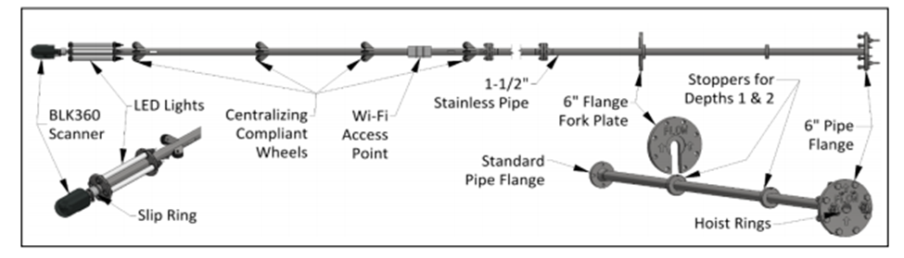

*Figure 3*: *Illustration of James Fisher Technologies LiDAR assembly LiDAR on a Stick (LiDS)*

LiDS consists of four dimmable Light Emitting Diode (LED) that “ strips for illuminating the light deprive environment and whose intensity is controllable from the above ground station” (Catert et al. 10), a Wi-Fi access point, “mounted at the top bottom section of the pole to bridge the communication network from the underground LiDAR to the above ground remote-control station where a second Wi-Fi access point is located” (Carter et al. 10), and centralizing wheels which are “located on the lower portion of the pole for scanner stabilization in the high wind velocity of the tunnel” (Carter et al.10).

The Leica BLK360 LiDAR scanner is placed at the bottom of the assembly, where the unit will be inserted head first into the pitot tube, a 6-inch pipe penetration through the tunnel ceiling, location of the exhaust tunnel. The LiDAR assembly was shipped to SRS, subsequent its completion, to begin the first deployment. During the first deployment, a crane is used to deploy the assembly down the pitot tube location of the exhaust tunnel. Scans are obtained at three different locations (top, middle, bottom) within the tunnel’s interior for a comprehensive point cloud. Figure 4 shows a concept illustration of deployment at 3 different elevations.

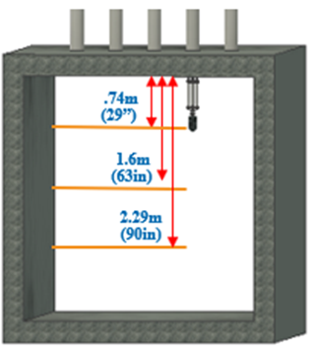

*Figure 4*: *Concept illustration of LiDS capturing scans of tunnel interior at 3 separate elevations*

The scanning process is done by Leica BLK360, as shown in Figure 5, sending out a beam of light (laser) recording the distance between the unit and the surface of the interior and the amount of time it takes for the light to hit the walls of the tunnel and reflect back to its sensors. The scanner is calibrated to scan 360,000 points per sec while rotating 360° in 180 seconds (3 min).

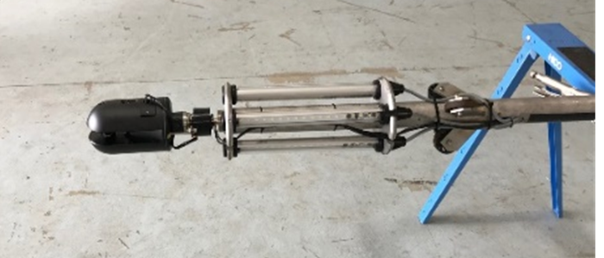

*Figure 5*: *Close up image of Leica BLK360 at the end of the assembly*

Using the distance, the angel of the mirror when the beam of light was sent, and the direction the unit was facing, the Leica BLK360 can calculate the location of a particular 3D point in space. While using the Leica BLK360, all scans were obtained using 100% light intensity in high resolution and 3 Dimensional images, as shown in Figures 6 and 7. Additionally, the unit has a mirror that rotates around the horizontal axes. Once a point has been identified and calculated in space, the mirror slightly rotates and begins the process again measuring a point above the previous point calculated.

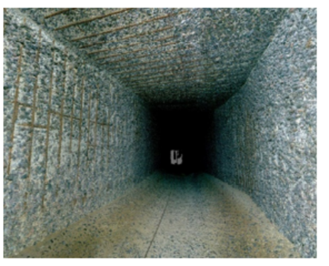

Figure 6: High- Resolution panoramic image of the interior of the tunnel

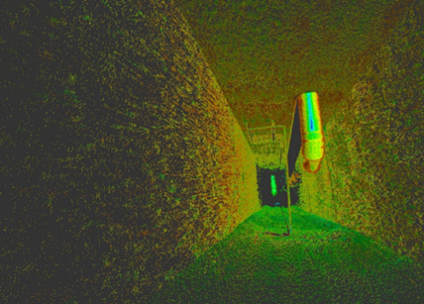

Figure 7: Partial view of 3D acquired point cloud

The range of scanned data collected encompasses almost 200ft of tunnel interior, as can be seen in Figure 8. Furthermore, the *November 2019 Initial Deployment of LiDAR* report asserts that, “for the purpose of collecting useable interior measurements, the Leica BLK360 is adjusted to a 0.25-in accuracy of each scan up to 30ft (east and west sides) on a level plane with no changes in configuration.” (Carter et al. 32) Captured measurements are uploaded to recap pro mobile to merge selected scans into single point clouds. Merged scans are transferred to recap pro on desktop and eventually stored for later post-processing.

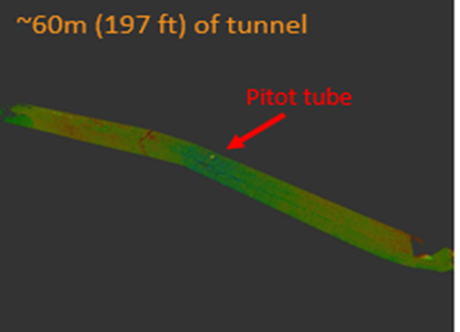

*Figure 8: 3 Dimensional image of 200ft scan of HCAEX tunnel*

Accessing of UofSC Virtual Private Network

Travel to the UofSC flagship campus, in Columbia, South Carolina, posed as an obstacle. Half of the group members resided in distant locations throughout the state of South Carolina, which meant that accessing the UofSC network on-campus would be costly option. Off-campus access to the UofSC network proved to be the best option for accessing the UofSC network since it spare time and financial resources for all members. Off-campus access to the UofSC network was done through the UofSC virtual private network (VPN). Acquiring access to the UofSC Virtual Private Network was a short process.

While searching the topic ‘virtual private network,’ several links emerge in connection with the search. Scrolling down the links, the link with the title ‘Off-Campus Access – University Libraries’ appears. Once this link has been opened, the link ‘virtual private network (VPN) client’ appears. Opening this link will lead to another page that has the title heading “What is the VPN?” Underneath the title heading appears a link for users with a windows operating system. This link leads to a page with the heading “Install and Connect to the VPN – Windows.” Just below the heading is the instructions section of the page. The instructions section briefly states what software (Cisco Anyconnect) to install in order to connect to the UofSC VPN and how to install the software with graphic instructions. In order to install Cisco Anyconnect, the instructions section prompts the link ‘software listings pages.’ Opening the link immediately requires a USC Network Username/VIP ID and Password login to the UofSC Central Authentication Service (CAS). Logging in will open the UofSC Software Distribution page with the headings ‘software for home’ and ‘software for work’. Since the objective was to access the UofSC network remotely, any link needed to be opened would be underneath the ‘software for home’ heading.

Underneath the ‘software for home’ heading, four tabs, with an option to expand them, appear:

* Microsoft Products – Home Use
* Qualtrics
* Security
* Statistics Software

Expanding the security tab will show seven more tabs for expansion:

* Cisco AnyConnect VPN for Faculty/Staff – Employee Home Use
* Cisco AnyConnect VPN for Students – Personal Use
* Microsoft Antivirus
* Sophos Antivirus
* Spirion (Identity Finder) – Employee Home Use
* Symantec Endpoint Protection – Employee Home Use
* USC Wireless Security Certificate

Clicking the Cisco AnyConnect VPN for Students – Personal Use will expose the Cisco AnyConnect VPN (Free Download) software link. Opening this link will lead to the official page of the Cisco AnyConnect VPN software where downloading can be executed. Subsequent software download, ciphering between the ‘Install and Connect to the VPN – Windows’ page and the ‘Connecting to the UofSC VPN’ link in the introductions section of the page will provide optimal direction in installing and connection to the UofSC VPN. Executing a finished application of Cisco AnyConnect Secure Mobility Client will exhibit a popup box that will prompt the user to connect to the UofSC VPN, as seen in Figure 9.

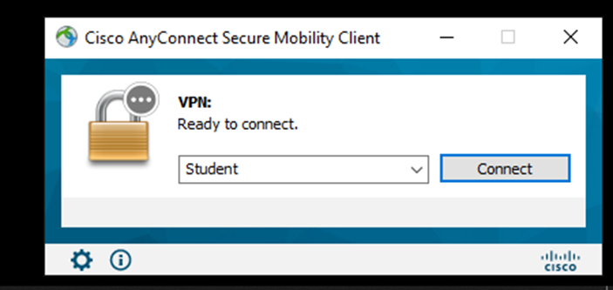

*Figure 9: Cisco AnyConnect Secure Mobility Client interface after installation*

Hyperion Account Creation and Access

Hyperion is one of the high-performance computing clusters stationed on the UofSC Columbia campus. Specifically, Hyperion is the UofSC “flagship cluster intended for large, parallel jobs and consists of 407 compute, GPU and Big Data nodes, providing 15,524 CPU cores. Compute and GPU nodes have 128 GB of RAM and Big Data nodes have 1.5 TB RAM.  All nodes have EDR infiniband (100 Gb/s) interconnects, and access to 1.4 PB of GPFS storage” (“HPC Clusters,” 2021). Compared to the SRNL multicore workstation with an NVIDIA Titan RTX GPU and Intel Core i9-7980XE CPU, Hyperion’s processing ability far exceeds that of the SRNL multicore workstation. Accessing Hyperion requires a research computing account with UofSC. The ‘Account Request’ tab can be found as an expansion tab under the ‘Research Computing’ tab on the UofSC research computing page. Clicking the ‘Account Request’ tab will lead to the Account Request page with two expansion tabs underneath the heading ‘Account Request:’

* Request an Account Here
* User Policies

Expanding ‘Request an Account Here’ exposes the ‘ticket here’ link underneath. Opening the ‘ticket here’ link leads to the UofSC Shibboleth Authentication page prompting the user Network Username and Password. Logging in will direct to the official research computing page allowing the selection of several options:

* Research computing account creation
* Academic research computing support
* General research computing consultation
* Software assistance
* High performance computing hardware assistance
* Other Research Computing Request

After the ‘Research computing account creation’ option is selected an order for an account request can be made by selecting the ‘Order Now’ button. The account creation process takes approximately two weeks to complete. Using both research computing account login information with Cisco AnyConnect Mobile Client login information, access to the Hyperion desktop, through the <https://login002.rc.sc.edu> graphical user interface link, will be is granted.

File-Sharing Process

Collected scans were saved in an .e57 format, a compact, vendor-neutral format for storing point clouds, images, and metadata produced by 3-Dimensional imaging systems, before they were transferred to a USB drive and distributed for post-processing on Hyperion. Opening data files on Hyperion with a USB hard-drive proved to be ineffective. USB drive access was blocked while on the UofSC VPN. Logging on to the Hyperion desktop provides a new desktop platform, taking over the physical desktop. On the Hyperion desktop, the USB drive directory is separate from the new directory created on Hyperion per the research computing account request. Therefore, instead of using a USB drive to upload data files, a File Transfer Protocol (FTP) application is needed to queue data files from the USB directory to the Hyperion directory in use.

FileZilla, a free software, cross-platform FTP application, proved to be an effective tool for transferring files over a secured network. Queuing data files over to the Hyperion directory in use requires access to Hyperion via FileZilla. FileZilla can be downloaded on official FileZilla website ‘FileZilla – The Free FTP Solution.’ Two enlarged download boxes appear on the website site titled ‘Download FileZilla Client’ and ‘Download FileZilla Server.’ The difference between the opposing downloading options is that FileZilla Client enables the transferring of files while FileZilla Server enables files to be made available to potential users. The Cisco AnyConnect Mobile Client is activated prior to the use of FileZilla.

Subsequent the connection to the UofSC VPN, the Host, Username, Password, and Port can be accessed on FileZilla. The following steps were executed in order to connect to Hyperion:

* Execute FileZilla application
* Expand File Tab
* Click Site Manager
* Create new site named Hyperion
* Expand protocal (under general tab)
* Click SSH File Transfer Protocol tab
* Type login.rci.sc.edu in Host space
* Type 222 in Port space

A small box will appear in the center of the screen prompting the user to enter a username and password. Providing that the username and password are correct, access to the Hyperion cluster has been granted. The Local site directory appears and USB drive can now be found. Any file needed to be queued over to the user’s Hyperion directed can be executed. SRNL’s LiDAR USB drive has 12 segment named folders (West, EastWest, East) of scanned data from the east and west sides of the tunnel. Most folders consist of 5 tunnel location named point cloud files (Ceiling, Flatfloor, Middle, North, South), however some have more than 5. Queuing all the falls to the user Hyperion directory took over two days to complete. Depending on the strength of the Wifi connection, the files in queue would terminate and connection to Hyperion would time out.

Processing of LiDAR data on CloudCompare through Hyperion

Equipped with both the <https://login002.rc.sc.edu> link and research computing account username and password, access to the UofSC open ondemand hpc dashboard was enabled. When directed to the open ondemand screen, four expansion tabs were immediately noticeable in the navigational pane of the page:

* Files
* Jobs
* Cluster
* Interactive Apps

Figure 10 exhibits the resulting open ondemand hpc dashboard.

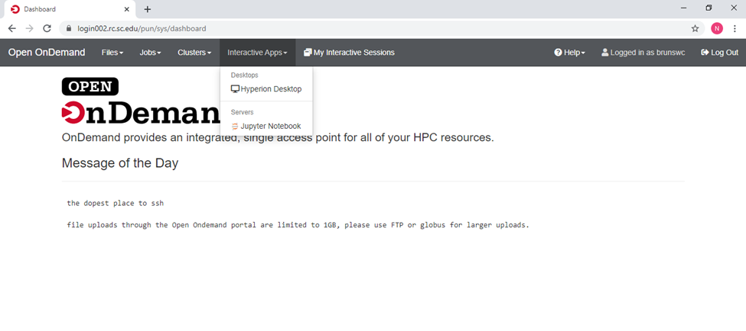

*Figure 10: Image of open ondemand Hyperion Desktop session page*

Expanding the Interactive Apps tab enabled the Hyperion Desktop application to appear. Clicking the HPC desktop application opened a page that granted the creation of a session on a random node on Hyperion, as seen in Figure 11. The option to control the number of hours on the node and number of cores requested was permitted. The maximum number of hours (8) and cores (28) requested were chosen with respect to the enormous amount of LiDAR data that needed to be processed and SRNL’s longest execution time (4 hours).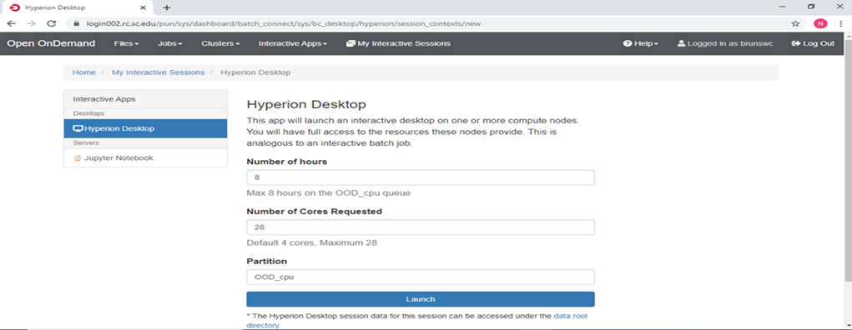

*Figure 11: Hyperion Desktop configuration page*

The succeeding page that resulted from launching the session exhibited the Hyperion desktop ID, host, time and date the session was created, session ID, compression meter, and desktop image quality meter. Adjustments were made to the image quality meter by raising the meter to its limit (9), as seen in figure 12. Launching the Hyperion desktop displayed the official Hyperion desktop, as seen in Figure 13.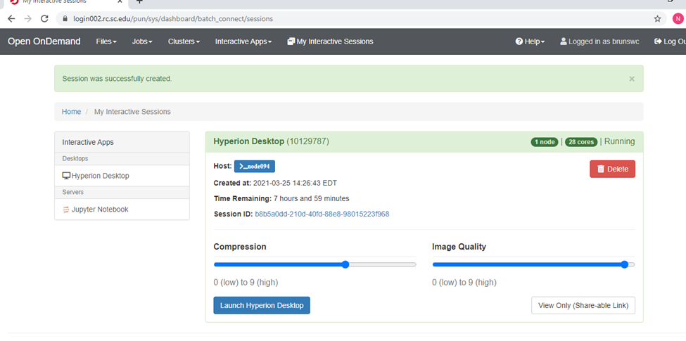

*Figure 12: Hyperion Desktop session confirmation page*

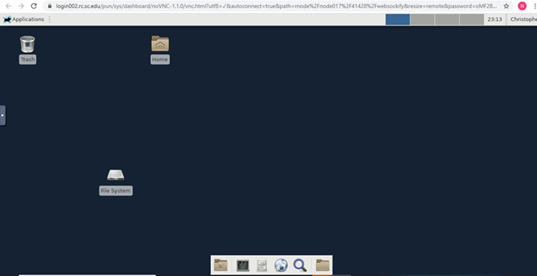

*Figure 13: Hyperion Desktop*

A version of CloudCompare needed to be established on the Hyperion database before the continuation of post-processing. Myk Milligan, a faculty member in the Research Cyber Infrastructure Department at UofSC Columbia, assisted with the implementation of establishing the CloudCompare 2.6.3.1 version on Hyperion. Two command lines were used on Hyperion’s terminal to execute the installed version of CloudCompare, as seen in Figure 14.

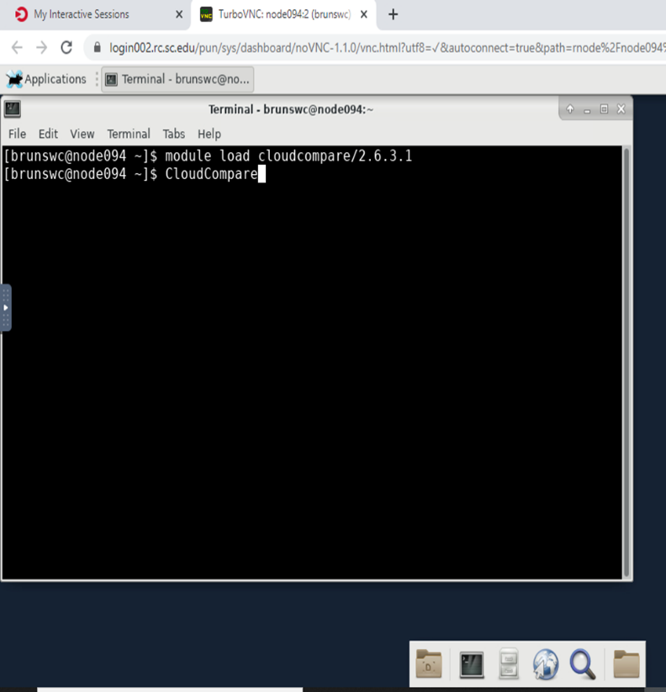

*Figure 14: Image of terminal with two command lines needed to execute cloudcompare*

To check to see if LiDAR data files were successfully queued to the user directory on Hyperion, the folder LiDAR, location used to save queued files on FileZilla, was opened in the brunswc directory. Numbered in ascending order, there are (5) east segment folders, (1) eastwest segment folder, and (6) west segment folders. Starting with the East1 titled folder ending with the West6 titled folder, cloud to cloud distance computation is performed on all (5) point clouds within each folder.

The cloud to cloud distance computation process consists of unique settings that need to be applied to all point clouds before computing the distance between a pair of point clouds, as can be seen in Figure 15. Each data point has a designated x, y, and z value constituting its location within a 3-Dimensional space. The first three columns represent the x, y, and z value of a particular point in space. The following three columns represent the column scheme of each point. The last two columns represent the direction in which each point was oriented during the scanning process. These settings were applied to all points to prevent the repetition of applying these settings. The coalition of the seven settings creates the point cloud image in CloudCompare.

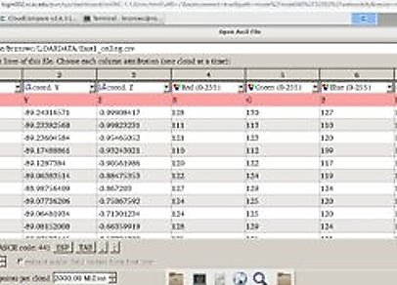

*Figure 15*: *American Standard Code for Information Interchange (ASCII) settings chart*

After clicking apply all, users were able to view a point cloud, as seen in Figure 16. To compare two point clouds, users would have to click two different point clouds on the DB tree. The point cloud would represent points from the ceiling, flatfloor, middle, North, and South locations of the tunnel. For each segment, users compared each point cloud as the following: The Ceiling to the flatfloor, North wall to the middle, South wall to the middle, North to South, and South to North point clouds.

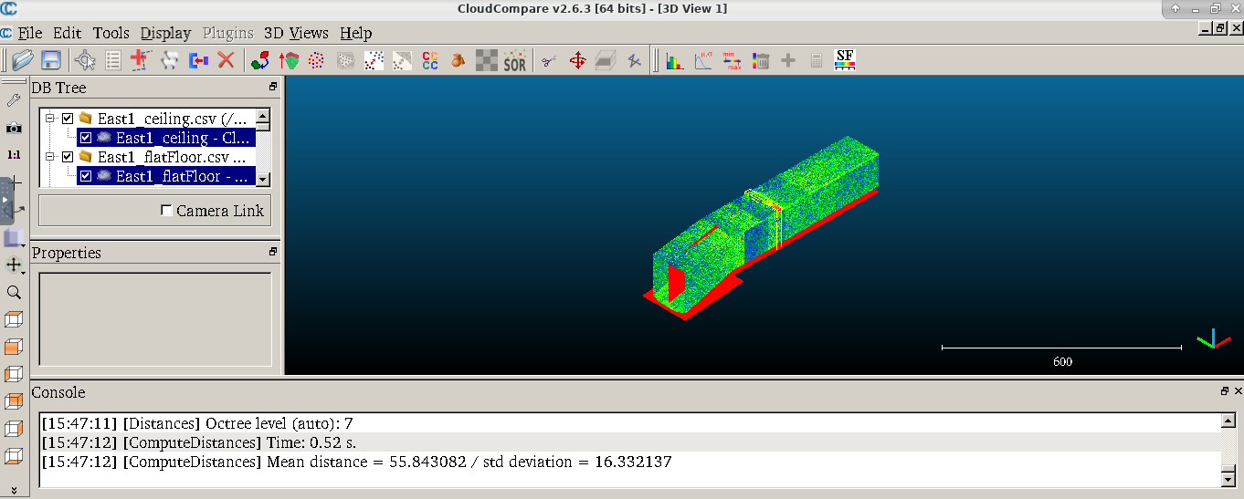

Figure 16: CloudCompare with Point Clouds

After clicking the first two-point clouds, users would click the tools tab in the navigation pane, as seen in Figure 17. Users would then click distances, and shortly afterward Cloud/Cloud Dist. This would allow the users to get the distance from comparing any two points.

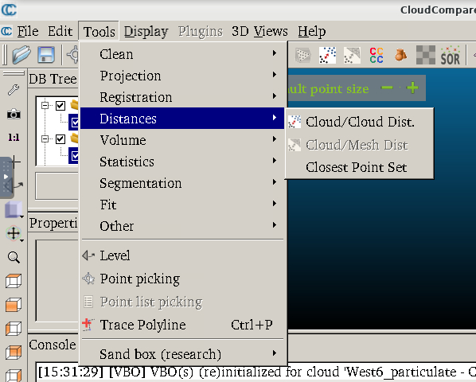

Figure 17: Tools Box

Then, a pop-up box is going to appear on CloudCompare. The pop-up box wants users to indicate the compared point to the reference point. For each segment, the ceiling is the compared point. Flatfloor, and middle are the reference points. South and North will be both the compared and reference point. Once users indicate the compared and reference points, the following step is to click ok on the pop-up box, as seen in Figure 18.

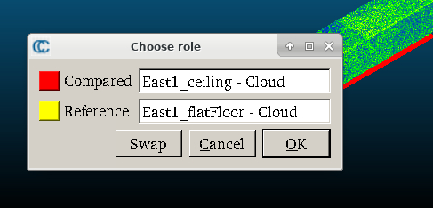

Figure 18: Compare/Reference

Figure 18 shows the following pop-up box that appears after clicking “OK.” A distance computation box would appear for users. There are three tabs on the Precise results. Users would click Local modeling to change some settings. Such as the Local model. The local model is 2D1/2 Triangulation. Also, users clicked on the radius area and typed .25 in that slot. After changing those two settings, users clicked compute on the bottom right on Figure 19. When clicking compute, another pop-up box will allow users to know that CloudCompare is processing the two selected point clouds. Once the two-point cloud has been processed, users would view the octree level, the distance between those two-point clouds, and the processing time. The processing time explains how long it took to compare those two-point clouds. Users have done this process for all 12 segments.

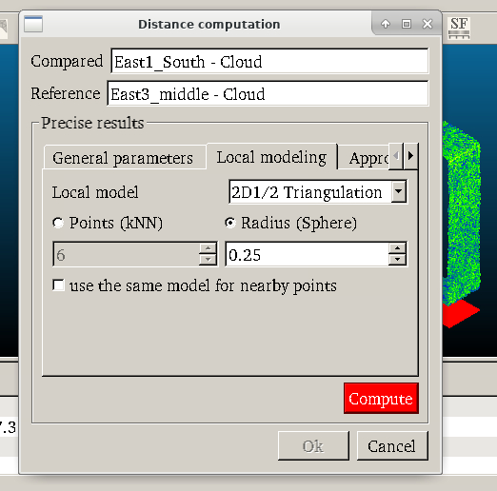

Figure 19: Distance Computation

LiDAR Processing Results

CloudCompare retrieved all measurements of 12 segments. When all 12 segments were retrieved, members of this group put all the distances on a table in an organized form to later compare the distances to the Savannah River Site to ensure all the data matched theirs. The two following figures show the Savannah River Site measurements and UofSC Aiken student’s measurements. Figures 20 and 21 show the difference in distance measurement SRNL Multicore workstation and UofSC Hyperion cluster. This was an indication that there were some corruptions while using CloudCompare. The two figures also show that the ceiling to artificial plan. North to Artificial Plan, North to South, and South to North of the wall contain many distances that did not match SRS. In Figure 21, the red indicates the distances that students received were lower than SRS’s measurements. The one yellow that is in Figure 21 represents that one distance was higher than SRS’s distance. After finding out that the dataset was not the same, more research had to occur.

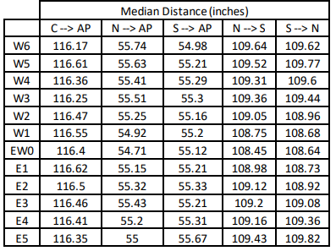

Figure 20: Distance Results Bbtained from SRNL Multicore Workstation

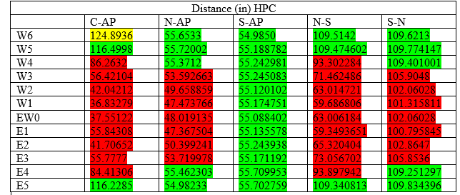

Figure 21: Distance Results Obtained from UofSC Hyperion Cluster

Shortly afterward, the mentors for this group instructed students to go on CloudCompare to view one segment. CloudCompare users opened the first segment, which is East 1, as Figure 22 shows. SRS’s mentors noticed that the figure 22 image looks incomplete; the top part of the image is the ceiling of this segment. Some point clouds were missing in the ceiling. Unfortunately, this was not the only segment that was missing some point clouds. Since the distances weren’t the same as SRS and having incomplete point clouds in this project, it was safe to say that some of the data has been corrupted.

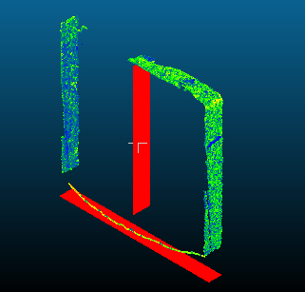

Figure 22: East 1 Segment

**Conclusion**

Since having corrupted data in this project, members-only viewed segments with a majority of good data, West 6, West 5, and East 5. As mentioned earlier in this report, this project aims to see if HPC process data faster than a Multi-core workstation. The tables representing the multi-core workstation and HPC execution times show that HPC processed those three segments slower than the Multi-Core workstation by 4 minutes. HPC could have processed those three segments slower because there is a chance that many people were using the same HPC at the same time, which could have affected the processing time. Since this group could not evaluate all the data, there was no conclusion made which computational device works the best overall, though processing LiDAR data on Hyperion resulted in slower processing times. The relation between the Multicore workstation processing time and Hyperion processing time can be seen in Figures 23 and 24.

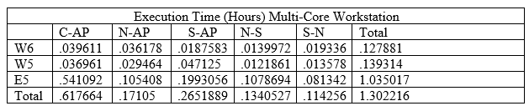

Figure 23: Multi-core Workstation's Processed Time

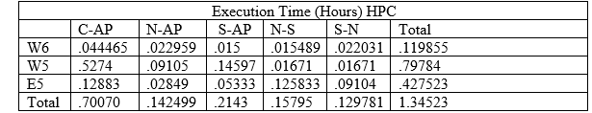

Figure 24: HPC'S Processed Time

In doing the LiDAR data processing evaluation: multi-core workstation versus high-performance computing project, Savannah River Site has a goal. The goal is to find the erosion rate from the H-Canyon tunnel. Since SRS started using LiDAR in November of 2019, there is not much data to determine the erosion rate. Therefore, this project will be ongoing until there is enough data to determine the erosion rate. Aside from finding the erosion rate, it is essential to see which computational device will be the fastest to process the enormous dataset collected from the LiDAR throughout time. In this project, SRS has compared multi-core workstation and noticed the processing time is prolonged. University of South Carolina Aiken students used high-performance computing to only HPC would process data faster than a multi-core workstation. At the end of this project, there was no solid conclusion on which computational device process data the fastest because of corrupted data; therefore, it is crucial to understand the real cause of the corrupted data.

**Future Work**

Future research consisting of both the SRNL multi-core workstation and UofSC Hyperion Cluster would delineate the causes behind LiDAR data corruption. Data corruption is the sole culprit behind inaccurate data processing and out-of-bound distances between point clouds. Understanding the origin of this problem would ultimately insure the veracity of future high performance computation on LiDAR data.

Work Cited

Minichan, R., Fogle, R., Marzolf, A. (2011). *H-canyon air exhaust tunnel inspection vehicle development*. Savannah River Nuclear Solutions. <https://digital.library.unt.edu/ark:/67531/metadc840277/>

Carter, J., Bowers, S., Plummer, J., Wells, W. (2020). November 2019 Initial Deployment of LiDAR in the H-Canyon Exhaust Tunnel. Retrieved from <https://www.osti.gov/biblio/1734661>​

Wells, Willie. (2020). H-Canyon Tunnel LiDAR on a Stick (LiDS). Retrieved from SRNL.DOE.GOV.​

*HPC Clusters*. (2021, April 20). University of South Carolina. Retrieved April 20, 2021, from <https://sc.edu/about/offices_and_divisions/division_of_information_technology/rc/hpc_clusters/index.php>

​